Mailing Address: PO Box 504, Franklin, NC 28744
Email: Secretary – normaschulman5@gmail.com
Website: www.MountainSynagogueWNC.com
Phone: (828) 634-1312

FEBRUARY 2024 newsletter

Next Shabbat Services
February 17th at 10:00 am

We hold in-person and online services on the third Saturday of each month.
Zoom Link for all services is https://us02web.zoom.us/j/87289809710

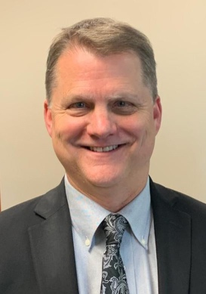
Yosi Knight
Our Spiritual Leader

President’s Message
Joel Edelson
Shalom, Y’all!

As I write this, it is a chilly 10 degrees on the thermometer outside, a bit unusual for our area. Unusual seems to be the norm these days in many parts and corners of the world.

Here at Mountain Synagogue, things are also unusual and getting busier as we begin to implement and make the improvements we requested through our FEMA grant.

We now have our dedicated internet system being installed, soon to be followed by our new camera and security system. Next will be our new doors and finally, our window enhancements. The final pieces include a generator and our improved outdoor lighting, which Duke already has installed.

As we look at our security enhancements, we have also made internal enhancements towards improving our worship environment. Thanks to John & Shari Rall and George & Joan Berman for constructing our new Torah table top, to improve our Saturday worship services by providing an easier way to roll our Torah scroll, and then read from it during services. Please come and look at the ingenuity that went into this simple improvement!

All in all, even with the unusual activities of the world still posing a reminder of the heartache that Israel and world face and endure, we are working hard here at home to make Mountain Synagogue a safe, accessible and secure place of gathering and worship.

We look forward to seeing you at our next service as well as our upcoming Passover Seder! Keep a lookout for updates!

B’shalom,

Joel

Joel Edelson
President
Board of Directors

Joel Edelson, President
Harvey Morse, Vice-President
Norma Schulman, Corresponding Secretary
Shayna Sinrich, Recording Secretary
Bobbi Serra, Treasurer
Donna Sinrich, Membership
David Goldstein
Michael Serra
Marcia Goldstein
Liz Hinckley

NOTICES AND ANNOUNCEMENTS

IF YOU HAVE SOME NEWS OR A SPECIAL EVENT THAT YOU WOULD LIKE SHARED IN OUR MONTHLY NEWSLETTER, EMAIL OUR EDITOR, HARVEY MORSE, AT harvey@probate.com

IMPORTANT NOTICE!

We are delighted to announce that several new members have joined our synagogue. To ensure everyone is familiar with our organization's rules and regulations, the Board is sending each new and existing member a copy of our By-Laws. Please keep an eye on your email.

Once you have received them, we kindly request that you acknowledge receipt by contacting our secretary, Norma Schulman, by clicking on her email here, normaschulman5@gmail.com and reply with a brief message stating "Received" and your name.

To ensure we fulfill our responsibilities, we ask all members to complete this as soon as possible. We appreciate your cooperation. Thank you.

MEMBERS’ MONTHLY SOCIAL Gathering
We hope you will join us!

Saturday, February 24th, 5 PM

VALLEY CAFE
7099 Highway 441 North
Dillard, GA 30537
(706) 746-3321

RSVP by February 22
George Berman
jrbgib1994@frontier.com
(828) 524-9463

MI SHEBEIRACH LIST
(PRAYERS FOR THOSE WHO ARE ILL)

ANN FERMAN
WENDY NEWMAN
JIM FIERBERG
RICHIE AARON
ALAN ESCOVITZ
BENJAMIN NEWMAN, MD
CONNIE CHESSER
SHARON SPIVEY
CAROL FELDMAN
MICHAEL SERRA
GEORGE LENKOWITZ

Yahrzeit donations
(Received by the 15th of the previous month)

Marcia Goldstein for her niece Melissa Carol Greenhut
Marilyn Mower for her father, Irving Solomon
Ed Pomerantz for his mother, Alice Pomerantz, and his grandmother, Sara Mitchell
Gary and Donna Sinrich for her brother, George Goldman, her father, Myles Webb,
and Gary’s mother, Elsie Sinrich
General Donations
Michael Levine
Lester Goldstein
Stuart and Jo Ann Raskin
Joshua and Nicki Isaacson

Tree of life

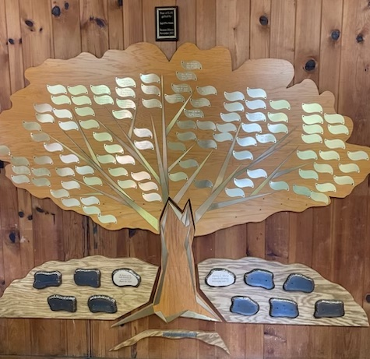

Our Tree of Life
Leaves are now available at $54 each (three times Chai), and large stones (only ten available) that will be mounted at the base are $500 each, engraving included. Contact us for details:
ms.treasurer79@gmail.com
Sasha Westerman-Keuning and her husband Dylan purchased a leaf celebrating
their Mountain Beginnings.
Members' Celebrations this month

BIRTHDAYS
Leon Hananel

ANNIVERSARIES
Joel and Laurie Edelson

Memorial Plaque Purchases
(Memorial plaques, which are located on the wall in our Social Hall, are $50 per name for an engraved, permanent remembrance).
Lester Goldstein purchased a plaque for his wife, Ellie Goldstein.

NEW MEMBERS WHO HAVE JOINED US
David and Wendy Newman

SAFETY TEAM MEMBERS NEEDED
We are continually seeking additional members to join our synagogue Safety Team. Approved members will receive appropriate training and will be covered by our insurance policy. If you are interested in serving, please get in touch with our Safety Director, Harvey Morse
(828) 631-0000 harvey@probate.com

Torah Table

Thanks to George and Joan Berman and John and Shari Rall,
for designing and building a Torah Table for our synagogue

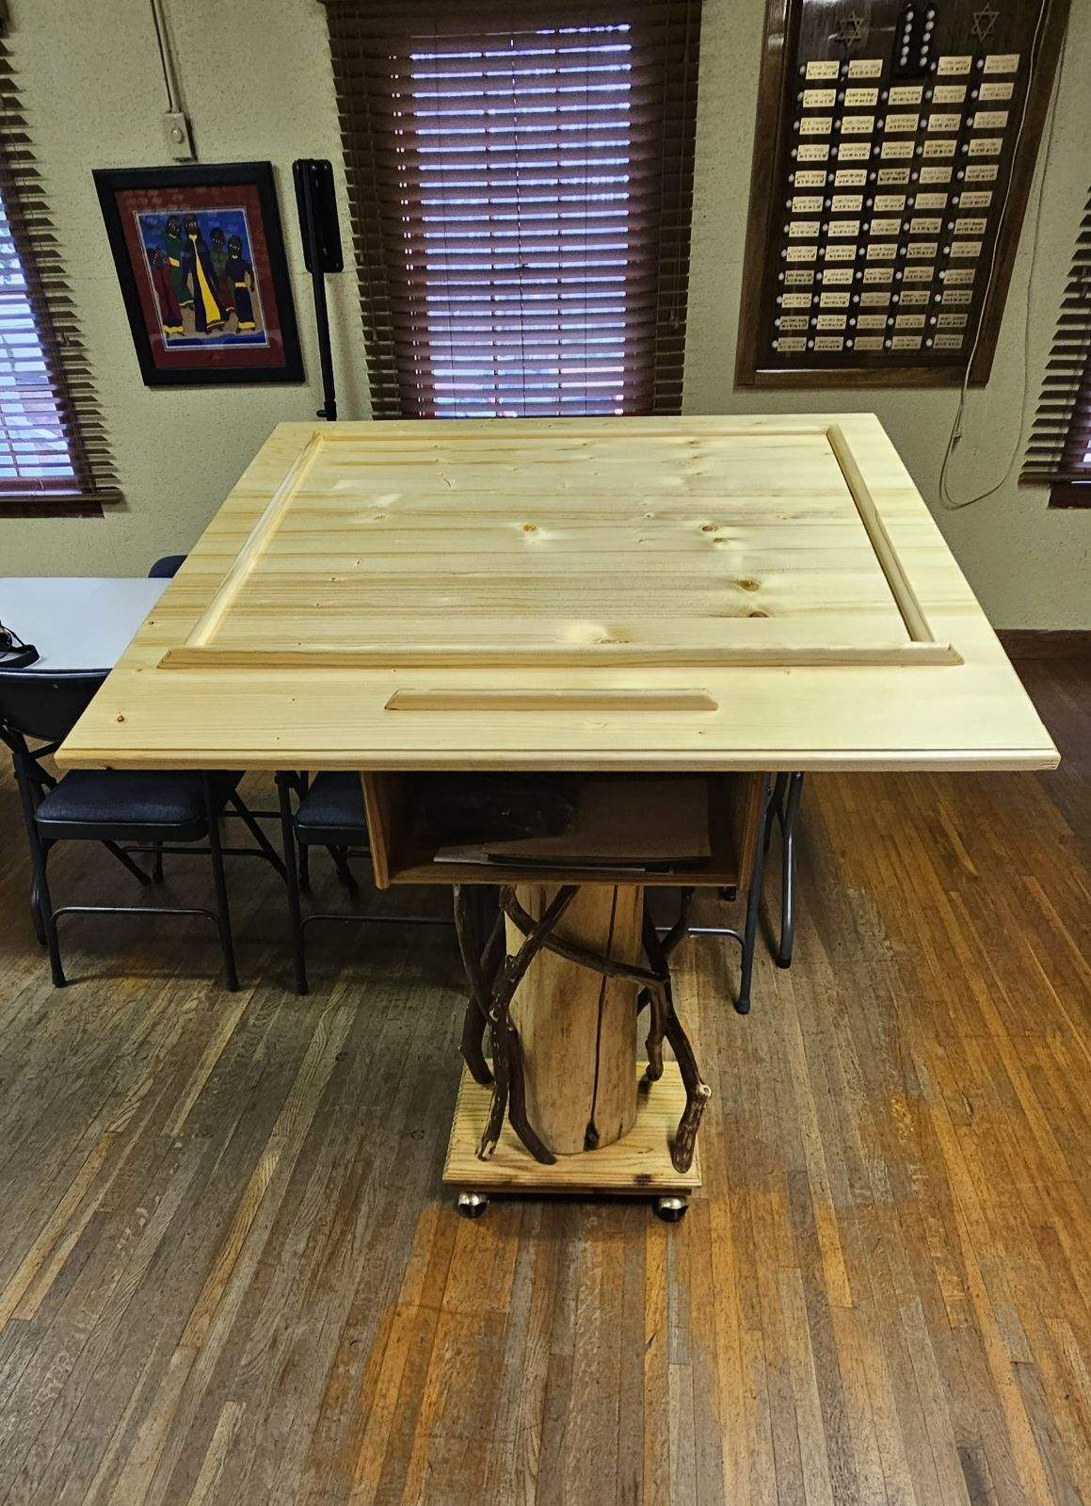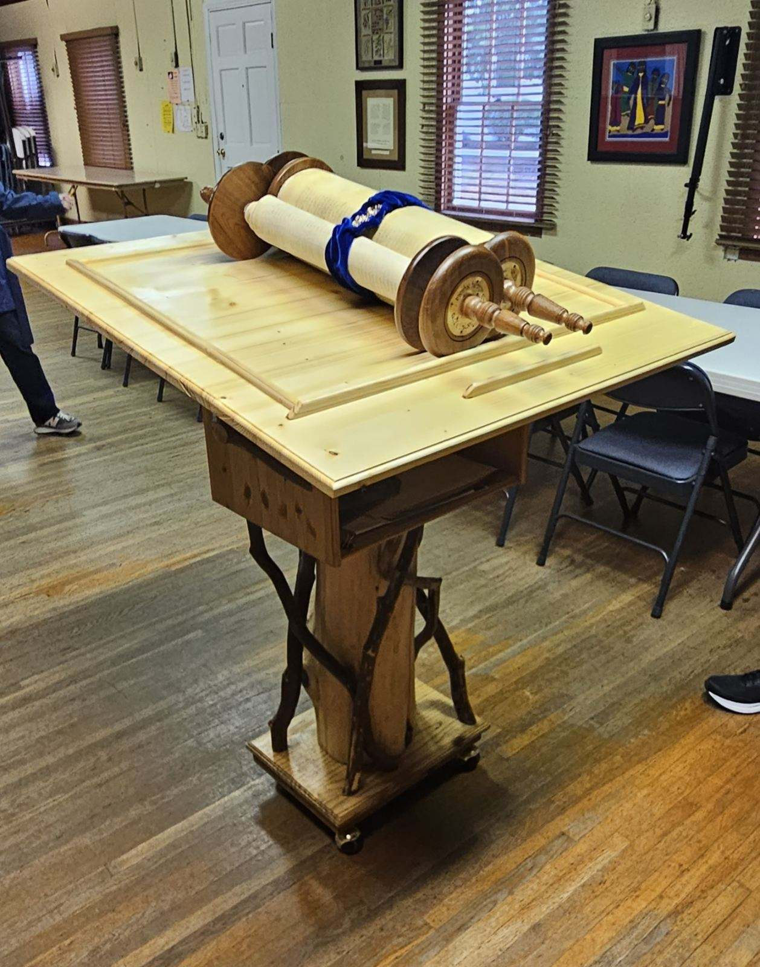

Absolutely Beautiful!

