MOUNTAIN SYNAGOGUE |  | Mailing Address: PO Box 504, Franklin, NC 28744  Email: MountainSynagogue@gmail.com  Website: www.MountainSynagogueWNC.com  Phone: (828) 634-1312
 | - december 2023
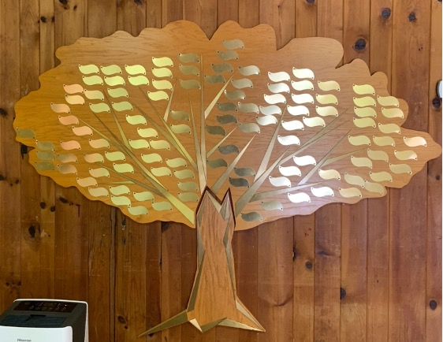  Our Tree of Life  Leaves are now available at $54 each (three times Chai) and large stones (only 11 available) that will be mounted at the base are $500 each, engraving included. Contact us for details:  ms.treasurer79@gmail.com |  | NEXT SHABBAT SERVICE  Saturday, December 16th at 10:00am  Followed by our Annual Meeting  Services are held on the third Saturday of each month both in-person and on Zoom.  For those members who prefer to attend via Zoom, please use the following link: https://us02web.zoom.us/j/87289809710  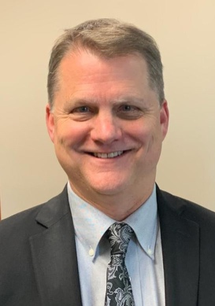  Yosi Knight  Our Spiritual Leader
Please watch your email and our website for notices regarding dates and times of services, which will be conducted both in-person and live online via Zoom.

NOTICES AND ANNOUNCEMENTS  - Have some news to share with our members? We want it all! Contact our newsletter editor, Harvey Morse at harvey@probate.com  - Mi Shebeirach (Prayers for the ill)  Ann Ferman  Wendy Newman  Jim Fierberg  Richie Aaron  Alan Escovitz  Benjamin Newman, MD  Connie Chesser  Shayna Sinrich  Sharon Spivey  Carol Friedman  - Yahrzeit Donations  (Received by the 15th of the prior month)  Zev Haselkorn for his father, Rabbi Arthur Haselkorn  Gary + Donna Sinrich for Donna’s mother,  Wilma Webb, and Gary’s father, William Sinrich  Andrea + Howard Slutsky for Andrea’s mother, Lilian Felman  Deb + Mike Arnold for Deb’s sister,  Diane Slavkin Benson  David + Marsha Snyder for Marsha’s  Mother, Linda Green  Mike + Bobbi Serra, for Mike’s father  Ralph Serra  Vickie Sanders for friend, Lillian Rothkopf and her aunt, Elise Hilda Willer  - General Donations  Lester + Ellie Goldstein, Carol Kitzner  and Beverly Barnett  - Member Celebrations This Month  Birthdays:  Harvey Morse, Sandra Weston, Renee Cohen, John Stemple, Pearl Goldfarb Marcia Goldstein, Celeste Strohl, Jacqueline Goldstein, Dylan Keuning  David Goldstein  Anniversaries:  George + Joan Berman  - Tree Of Life Leaf Purchases  Leaves are $54, and Stones are $500 each.  [Our Tree of Life is for celebrations, family or personal events of note, not memorials].  Mike + Bobbi Serra for their 50th Anniversary and 70th birthdays  - Memorial Plaques  Memorial plaques which are placed in our Social Hall are $50 per name for an engraved, permanent remembrance.  None  - New Members This Month  Michael Sligh + Janet Klompus  MEMBERS MONTHLY SOCIAL EVENT!  Saturday December 2nd at 5:00pm there will be a member’s dinner at:  Jaxson Downtown  381 Depot Street  Franklin  RSVP REQUIRED to George Berman  by November 30th  828-524-9463 or Email:  jrbgib1994@frontier.com |  | PRESIDENT’S MESSAGE  Joel Edelson, President  The Ripple Effect  Shalom, y’all. As this secular year winds down to a close, there is a lot to reflect on, be grateful for, and think forward regarding what we would like this next year to have in store for us.  For many of us, we might say “What can we do about what’s going on in the world? It’s just me! How can I make a difference?”  Well, on a large scale, you’re right, probably not a lot. However, if we focus our thoughts and efforts, perhaps we can make a big difference?  For those that joined us at our Interfaith Thanksgiving Service held on Tuesday evening, November 14, I think we can say in some small way, we DID make a difference here in our community. We brought multiple faiths together under a common cause, sharing our hopes, thoughts and prayers of Thanksgiving, while contributing in a nice way to filling our local food pantry with food and non-perishable goods that families in need will most certainly appreciate.  By sharing our prayers and dreams, songs and poems of Thanksgiving, we learned how similar we all actually are, and in fact we believe in many of the same things. Our commonality is what ties us together, and we can make a difference, however small it may seem, right here where we live.  On a global scale it’s hard to see how this small event can make a dent, but there is a thing called the Ripple Effect. When you toss a small pebble into a lake or pond, that small pebble will resonate outwards until those small waves cover the entire pond! That is what is possible by our small acts of faith or kindness, as these “ripples” carry forward, and who knows, can possibly make a large impact for someone far removed from our first act, our first pebble.  Let’s keep our “kindness pebbles” moving in a direction where, perhaps, one day the planet will be covered in acts of kindness.  B’shalom,  Joel  SAFETY TEAM MEMBERS NEEDED  We are continually seeking additional members to join our synagogue Safety Team. Approved members will receive appropriate training and will be covered by our insurance policy. If you are interested in serving, please contact our Safety Director at: harvey@probate.com  HAVE A COMPUTER? DO YOU ENJOY WRITING? USE MICROSOFT WORD?  We are looking for a member who would like to assist with our monthly newsletter. Please contact Harvey Morse at harvey@probate.com for details.  ANNUAL CONGREGATIONAL MEETING  Our Annual Meeting and election of Officers  will take place after services on  Saturday, December 16th, 2023  The meeting will be followed by a “Pot Luck” lunch!
www.MountainSynagogueWNC.com | PHONE: 828-634-1312 |
EMAIL: MountainSynagogue@gmail.com

