Mailing Address: PO Box 504, Franklin, NC 28744
Email: MountainSynagogue@gmail.com
Website: www.MountainSynagogueWNC.com
Phone: (828) 634-1312

March 2024 newsletter

Next Shabbat Services
March 16th at 10:00 am

We hold in-person and online services on the third Saturday of each month.
Zoom Link for all services is https://us02web.zoom.us/j/87289809710

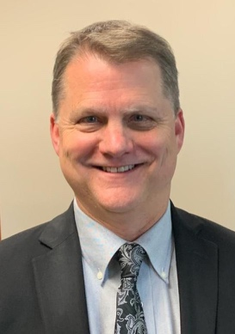
Yosi Knight
Our Spiritual Leader

President’s Message
Joel Edelson
Shalom, Y’all!

Purim and Pesach: Two Models Of Redemption

Adapted from Rabbi Dr. Kenneth Brander
We will soon celebrate both Purim and Passover (Pesach. The holidays of Purim and Pesach are observed in fairly similar ways: Both holidays are centered around feasting. While the tone of the Purim story differs from that of the Pesach seder, they are both times that we gather around the table for a festive meal, above-average drinking, and joyous celebration. To make these celebrations possible, we make it a high priority to donate to the poor to ensure that they too can take part in the festivities, be that through matanot la’evyonim on Purim or kimcha d’Pischa in the lead-up to Pesach and an invitation to the poor to eat with us at the Pesach seder.
Each of these celebrations is coupled with the recounting of the story – on Purim through the Megillah reading, and on Pesach through the recitation of the Haggadah.
Looking further, we see that the holidays themselves are interlinked with one another. Normally we have the tradition of performing a mitzvah at the first opportunity. What’s more, Purim occurs exactly a month before the first day of Pesach, making it the first day we are meant to study the laws of Pesach in preparation for the upcoming holiday.
Furthermore, upon careful reading of Megillat Esther, we discover that Esther’s soirée with Achashverosh and Haman, and Haman’s sentencing to the gallows, took place on the first days of Pesach! This remarkable occurrence (mentioned in the piyut “Vayehi Bachatzi Halayla,” recited at the conclusion of the seder) leads the Magen Avraham (OC 490:1), to suggest that we should add an extra dish to our holiday meal on the second day of Pesach to express our gratitude for the downfall of Haman which occurred on that day.
Yet even as Purim and Pesach share commonalities and connections, the underlying stories and themes of the two holidays are different from each other. Contrary to the book of Shemot, the Haggadah hardly makes a single reference to Moses (early manuscripts of the Haggadah contain no references to Moses) in its recounting of the Exodus narrative. Hashem, it seems, is entirely at the reins, and the human actors, even those at the level of Moses, are overlooked. But the opposite is the case regarding Purim. In the book of Esther it is Hashem who gets sidelined, so to speak, failing to earn a single mention in the whole Megillah!
The distinction in whose name is missing is, in fact, reflective of the larger thematic difference between Purim and Pesach. Pesach marks the very beginning of the relationship between the Jewish people and Hashem. In its infancy, with the Jewish people bereft of mitzvot, it is God who works wonders in order to save the Jewish people. Yet in the Purim story, which comes at the tail end of Tanach, when prophecy is over, the Jewish people are led by Esther and Mordechai, gather together in prayer, take initiative, and, with God’s ever-present yet invisible hand guiding them, bring about their own redemption.
As we make our way through this season of festivals of redemption, may we never forget to have faith in God, and faith in ourselves, so we can be partners with the Divine in hastening the redemption of the Jewish people and all of society.
Eat, drink and be merry!

B’Shalom,

Joel

Board of Directors

Joel Edelson, President
Harvey Morse, Vice-President
Norma Schulman, Corresponding Secretary
Shayna Sinrich, Recording Secretary
Bobbi Serra, Treasurer
Donna Sinrich, Membership
David Goldstein (New Member)
Michael Serra
Marcia Goldstein
Liz Hinckley (New Member)

NOTICES AND ANNOUNCEMENTS

IF YOU HAVE SOME NEWS OR A SPECIAL EVENT THAT YOU WOULD LIKE SHARED IN OUR MONTHLY NEWSLETTER, EMAIL OUR EDITOR, HARVEY MORSE, AT harvey@probate.com

MEMBERS’ MONTHLY SOCIAL Gathering
We hope you will join us!

RSVP is required by March 7th
Contact George Berman at jrbgib1994@frontier.com or call (828) 524-9463

MARCH 9th at 5:00pm
Las Margaritas Mexican Restaurant
24 Lotla Street
Franklin

MI SHEBEIRACH
(PRAYERS FOR THOSE WHO ARE ILL)

ANN FERMAN
WENDY NEWMAN
JIM FIERBERG
RICHIE AARON
ALAN ESCOVITZ
BENJAMIN NEWMAN, MD
CONNIE CHESSER
SHARON SPIVEY
CAROL FELDMAN
MICHAEL SERRA
HOWARD SLUTSKY
PHYLLIS AND JAY SHANES

Yahrzeit donations
(Received by the 15th of the previous month)

Deb and Mike Arnold for Deb’s grandmother, Jenny Slavkin
Karen Sami for her husband, Samuel Benson Sami
Michael and Bobbi Serra for Bobbi’s mother, Anna Whittemore

General Donations
None
Members' Celebrations this month

Birthdays
Ray Jeroslow
Stuart Weston
Doris Dingott
Michael Serra

Anniversaries
Gary and Donna Sinrich

SAFETY TEAM MEMBERS NEEDED
We are continually seeking additional members to join our synagogue Safety Team. Approved members will receive appropriate training and will be covered by our insurance policy. If you are interested in serving, please get in touch with our Safety Director, Harvey Morse
(828) 631-0000 harvey@probate.com

Tree of life

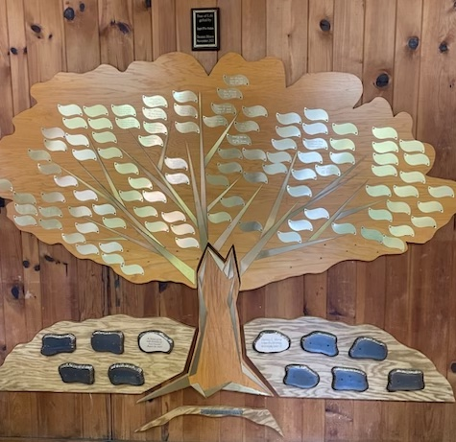

Our Tree of Life
Leaves are now available at $54 each (three times Chai), and large stones (only 10 available) that will be mounted at the base are $500 each, engraving included. Contact us for details:
ms.treasurer79@gmail.com

No purchases this month

Memorial Plaque Purchases this month
(Memorial plaques, which are located on the wall in our Social Hall, are $50 per name for an engraved, permanent remembrance).
None this month

NEW MEMBERS WHO HAVE JOINED US
None this month

A PURIM MESSAGE from Yosi
March 2024/5784

This year Purim is celebrated on Sunday, March 24. This is one week after our monthly Shabbat service which falls on March 16. Purim is our second winter festival, Chanukah being the first. Like Chanukah (and unlike the High Holidays), there is no prohibition against working.

Purim is usually observed on the 14th day of the Jewish month of Adar. However, this year we have Adar I and Adar II. Our rabbis “correct” our lunar calendar with an extra month (Adar I) every 2 or 3 years, and not an extra day (February 29) every 4 years. Purim occurs a month before Passover every year.

There are three traditions unique to Purim:
- To listen to the scroll of Esther chanted or read,
- To “eat, drink, and be merry,”
- To send gifts of food and/or drink called the “sending out of portions” or shalach manot (Esther 9:20-23 & 27).
In many communities, it has become customary to wear costumes, hold parades and parties, and even perform dramas of the story of Esther.

While we may not be together this year, it is good to know and remember Purim. There is an enjoyable, short animation of the story of Esther on YouTube: Book of Esther: A Complete Animated Overview.
Yosi

Membership Directory Update

Mountain synagogue is updating all member information for our next directory.

In the future, we will send only one newsletter per membership household to the ‘Primary” email, but all emails will be included in the directory. We ask that you include names with the cell phone numbers and birthdates.

Special events cover anniversaries and other yearly events. For special events such as new births, graduations, and celebrations, etc., please send the information to ms.treasurer79@gmail.com to include it in our monthly newsletter. The cutoff date for submission for the newsletter is the 15th of the previous month.

We are updating our Yahrzeit list; please list the Yahrzeits you would like to be recognized during services.

Please complete and return the attached form by March 15.(The form is attached and is printed below for your convenience)

By email: ms.treasurer79@gmail.com

By post:
Mountain Synagogue
PO Box 504
Franklin, NC 28744

Donna W. Sinrich
Mountain Synagogue Membership Chair

INFORMATION FORM IS ON THE NEXT PAGE

MOUNTAIN SYNAGOGUE

P.O. BOX 504

FRANKLIN, NORTH CAROLINA 28744

mountainsynagogue@gmail.com

www.mountainsynagoguewnc.com

Membership Information

Jan – Dec. 2024

Family Membership $200.00

Individual Membership $125.00

PLEASE PRINT
Today’s Date:

Member(s) Name(s):

Summer Mailing Address:

Summer Telephone Number:

Primary E-mail Address for announcements and the newsletter:

Other E-mail Addresses>

Winter Mailing Address:

Winter Telephone Number:

Cell Phone(s): Please list by name:

Birthday(s): Please list by name:

Special Events:

Yahrzeits: Please list by name, relationship & date:
MS President Joel Edelson received the 2023 Top Producer and Agent of the Year Award, from the Master Delaney Agency in Symmetry Financial Group, for overall production and support of other agents.

CONGRATULATIONS!

