MOUNTAIN SYNAGOGUE |  | Mailing Address: PO Box 504, Franklin, NC 28744  Email: MountainSynagogue@gmail.com  Website: www.MountainSynagogueWNC.com  Phone: (828) 634-1312
 | - OCTOBER 2023
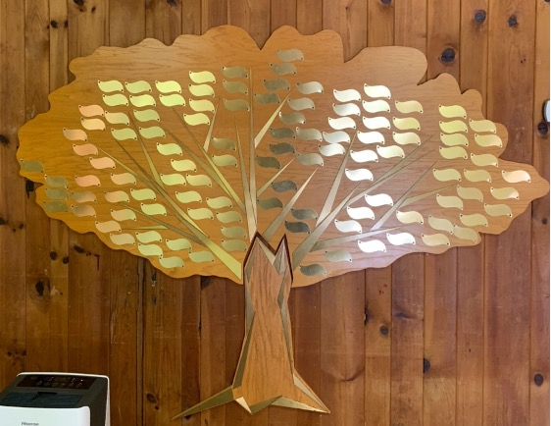  Our Tree of Life  Leaves are now available at $54 each (three times Chai) and large stones (only 11 available) that will be mounted at the base are $500 each, engraving included. Contact us for details:  ms.treasurer79@gmail.com |  | NEXT SHABBAT SERVICE  Saturday, October 21st at 10:00am (See below)  Services are held on the third Saturday of each month both in-person and on Zoom.  For those members who prefer to attend via Zoom, please use the following link: https://us02web.zoom.us/j/87289809710  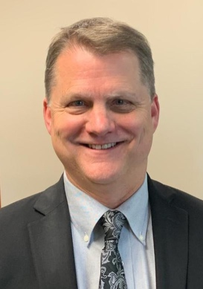  Yosi Knight  Our Spiritual Leader
Please watch your email and our website for notices regarding dates and times of services, which will be conducted both in-person and live online via Zoom.

NOTICES AND ANNOUNCEMENTS  - Have some news to share with our members? We want it all! Contact our newsletter editor, Harvey Morse at harvey@probate.com  - Mi Shebeirach (Prayers for the ill)  Ann Ferman  Wendy Newman  Jim Fierberg  Richie Aaron  Edith Finegold  Alan Escovitz  Benjamin Newman, MD  Connie Chesser  Laurie Edelson  - Yahrzeit Donations  (Received by the 15th of the prior month)  Lee Berger for Husband Dr. Fred Berger  Mike Serra for Mother, Ann Serra  - General Donations  Harvey Morse  Rothkopf Greenberg Family Foundation Trust/Helene Prokesch in honor of  Vickie Sanders  - Member Celebrations This Month  Birthdays:  Robert Rosenfeld, Allan Baer, Shayna Sinrich, Stephanie Lunsik, Kylie Keuning  Anniversaries:  None  - Tree Of Life Leaf Purchases  Leaves are $54, and Stones are $500 each.  [Our Tree of Life is for celebrations, family or personal events of note, not memorials].  None  - Memorial Plaques  Memorial plaques which are placed in our Social Hall are $50 per name for an engraved, permanent remembrance.  None  - New Members This Month  David & Elizabeth Goldstein and daughter Jacquelyn Goldstein  Don and Donna Gaber  Sasha Westerman-Keuning, Dyland & Kylie Keuning.  New Members: Continued  Michael Bildner  Steven & Ann Marie Kantor  Wilfred & Cynthia Gaier  Marc & Karen Schneir  Lester & Callie Goldstein  MEMBERS SEPTEMBER’S SOCIAL EVENT!  Saturday October 28th at 5:00pm there will be a member’s dinner at:  JAXSON’S DOWNTOWN PIZZA  381 Depot Street  Franklin, NC  RSVP REQUIRED to George Berman  by OCTOBER 26th  828-524-9463 or Email:  jrbgib1994@frontier.com |  | PRESIDENT’S MESSAGE  Joel Edelson, President  Dear Yosi, Board of Directors, and Congregation,  I wanted to take a moment to express my heartfelt appreciation for the incredibly meaningful Jewish High Holiday services we experienced this year. It was truly a memorable and spiritually uplifting time for all.  First and foremost, I would like to extend my deepest gratitude to Yosi, our Spiritual Leader for conducting our services, to the talented cellist provided by Norma Schulman, whose enchanting melodies added a remarkable depth to the service. His masterful skills on the cello transported us to a place of introspection and connectedness with our Jewish heritage. The captivating music resonated deeply with everyone present and created an atmosphere of reverence and serenity.  Additionally, I want to express my appreciation to Yosi for the memorable Rosh Hashana and Yom Kippur services. His prayer recitations, the thought-provoking words and explanations, and the collective sense of unity within the congregation all combined to create truly powerful moments. The spiritual journey we embarked upon during these holy days was made even more profound because of the passionate efforts of his expertise and skills, together with the active participation of everyone present.  I would also like to thank the Board of Directors for their hard work and dedication in organizing these High Holiday services. Their attention to detail and commitment to providing a meaningful experience did not go unnoticed. From the stunning flowers provided by Vickie Sanders to the seamless coordination, it was clear that much thought and effort had been put into making these days unforgettable. A special thanks to Norma Schulman for organizing the Break-Fast and to those who assisted her, and thanks to the Berman’s for setting up the sanctuary.  I feel incredibly blessed to be part of this vibrant community as the President of Mountain Synagogue, and to be able to celebrate these and other significant Jewish holidays together with all. The warm and welcoming atmosphere, coupled with the meaningful rituals and traditions, have made these High Holiday services and all of our services throughout the year, an experience to cherish and remember.  Once again, thank you, Yosi, for your remarkable leadership, thank you to the Board of Directors, to Harvey Morse and our Safety Committee, and to our entire congregation for your unwavering dedication to creating a truly meaningful Jewish High Holiday service and support of Mountain Synagogue. May the spirit of these Holy Days continue to guide and inspire us throughout the year.  Wishing you all a year filled with health, happiness, and peace.  B’Shalom,  Joel  SAFETY TEAM MEMBERS NEEDED  We are continually seeking additional members to join our synagogue Safety Team. Approved members will receive appropriate training and will be covered by our insurance policy. If you are interested in serving, please contact our Safety Director at: harvey@probate.com  HAVE A COMPUTER? DO YOU ENJOY WRITING? USE MICROSOFT WORD?  We are looking for a member who would like to assist with our monthly newsletter. Please contact Harvey Morse at harvey@probate.com for details.
WWW.MOUNTAINSYNAGOGUEWNC.COM | PHONE: 828-634-1312 |
EMAIL: MountainSynagogue@gmail.com

